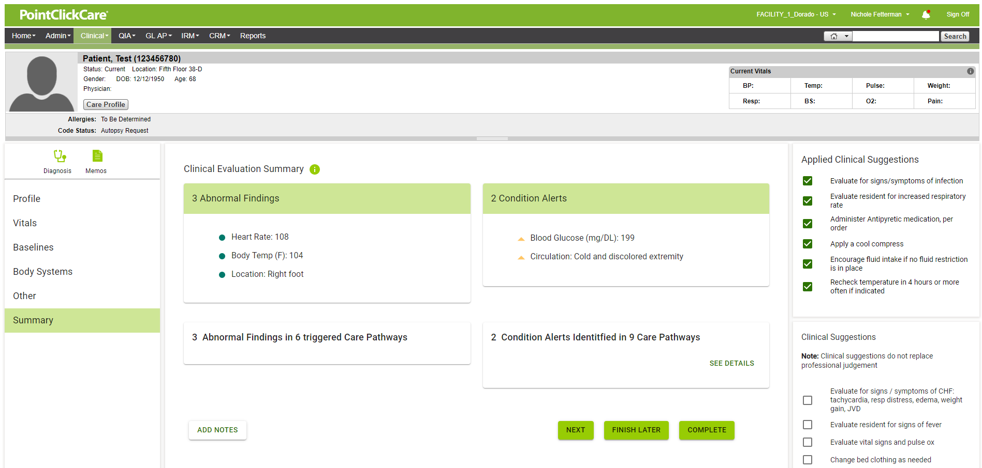



Screen 1: Insert Stella Smith’s header

Make location right foot a Condition alert. It will then read 2 Abnormal Findings and 3 Condition Alerts

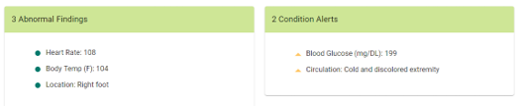

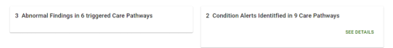

Screen 2:

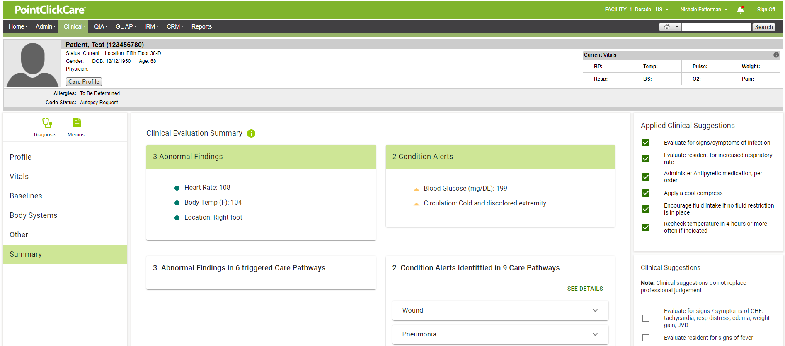

* 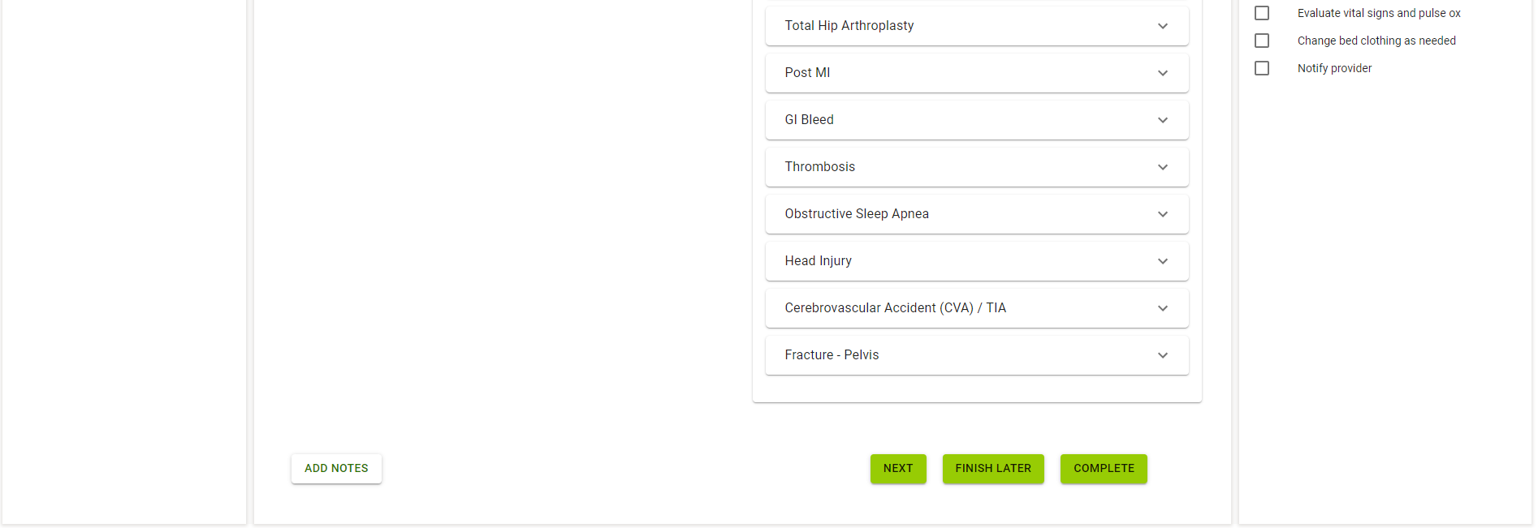

Insert header.

Make changes above to the top of the screen

Only show the following (instead of the 9 that are in view)

Total Hip Arthroplasty

Thrombosis

Diabetes

Infection – General

Change labels to say 3 condition alerts identified in 4 untriggered care pathways

Change label to say 2 abnormal findings in 4 care pathways

Screen 3:

Once you get these two done we will do screen three. There will be a lot of tweaks it will be easier this way (I think 😊).

